Denmark Grocery Budget Agent
The Gen Academy — Week 3 Project — Agentic System Documentation

1. The One-Liner
My agent helps a grocery shopper in Denmark turn a plain-language request into a priced, sourced comparison across nearby supermarkets, in a Streamlit chat interface, replacing the manual habit of checking two or three store apps by hand and guessing which one is actually cheapest. It reasons about which of two tools to call - pricing the list, and, only when explicitly instructed, placing a mock order - rather than following a fixed script, using three real data tiers (this week's real Netto deals via a Pinecone-backed RAG pipeline, live REMA 1000 prices, and a labelled estimate model for everything else), and I'll know it works when a user can go from a free-text request to a correctly-priced, clearly-labelled comparison across real nearby stores in under a minute.

2. The Framework
Field | Answer
Agent goal | Given a free-text grocery request (items, a Danish address, optionally a budget), find nearby supermarkets, price the list, and - only if explicitly instructed - place a mock order at the cheapest option.
Where do people use it? | A Streamlit chat interface (single page): type a natural-language request, get back a plain-language answer plus store cards with prices.
What steps does it take, in order? | There is no fixed step order. A single LLM orchestrator (GPT-5.4) reads the message and decides, per request: whether to call find_and_price_groceries (which internally geocodes the address, finds nearby stores, prices every item at every store across three tiers, and ranks single-store vs. split-store plans), and separately whether the wording is an explicit, present-tense instruction to place an order, in which case it calls place_mock_order.
What can it actually do? | Reads (autonomous): geocode an address, find nearby supermarkets, look up real weekly deals and live prices, fall back to an estimate model, rank plans. Writes: place_mock_order writes a confirmed mock order record immediately when instructed - there is no real payment, checkout, or delivery integration, and no external system is touched.
What does it need to remember? | Within a session: the full conversation, via a LangGraph checkpointer keyed by a per-browser-session thread id, so a later turn ("apples, place the order") can reuse an address or item list given earlier. Across sessions: a SQLite table of confirmed mock orders, shown in the sidebar as order history.
What should it never do? | Never claim a price is real when it isn't - every price is tagged real or estimated, with a link to its source when real. Never silently drop an item it couldn't price - unpriced items are always listed. Never touch a real payment or delivery system (there isn't one to touch). Never restate an old turn's price as if it were fetched just now.
Human-in-the-loop | Deliberately not present for the mock order action, on the project owner's explicit instruction. place_mock_order confirms an order the moment the orchestrator judges the user gave a direct, present-tense instruction to order - there is no separate human confirmation step. This trade-off is discussed under Known Limitations below.
What happens when something breaks? | Store search tries Google Maps first (if configured) and falls back to OpenStreetMap on any failure, always labelling which one actually ran. Pricing tries three tiers in order - this week's real Netto deals (Pinecone + OpenAI embeddings), live REMA 1000 lookup, then a labelled estimate model - and degrades tier by tier rather than failing outright. An item with no match anywhere is reported as unpriced, never guessed.
How do you know it worked? | A user can type a plain-language grocery request and get back a correctly-priced, clearly-sourced comparison across real nearby stores in under a minute, with real prices used whenever they exist and estimates clearly flagged when they don't.

3. Agent Architecture
The system is a single LLM orchestrator (GPT-5.4, via LangChain's create_agent) that reads a user's free-text message and decides, itself, which of two tools to call and with what arguments. This is the single ReAct agent pattern: one model reasons over the conversation and calls tools as needed, rather than following a fixed sequence of steps.
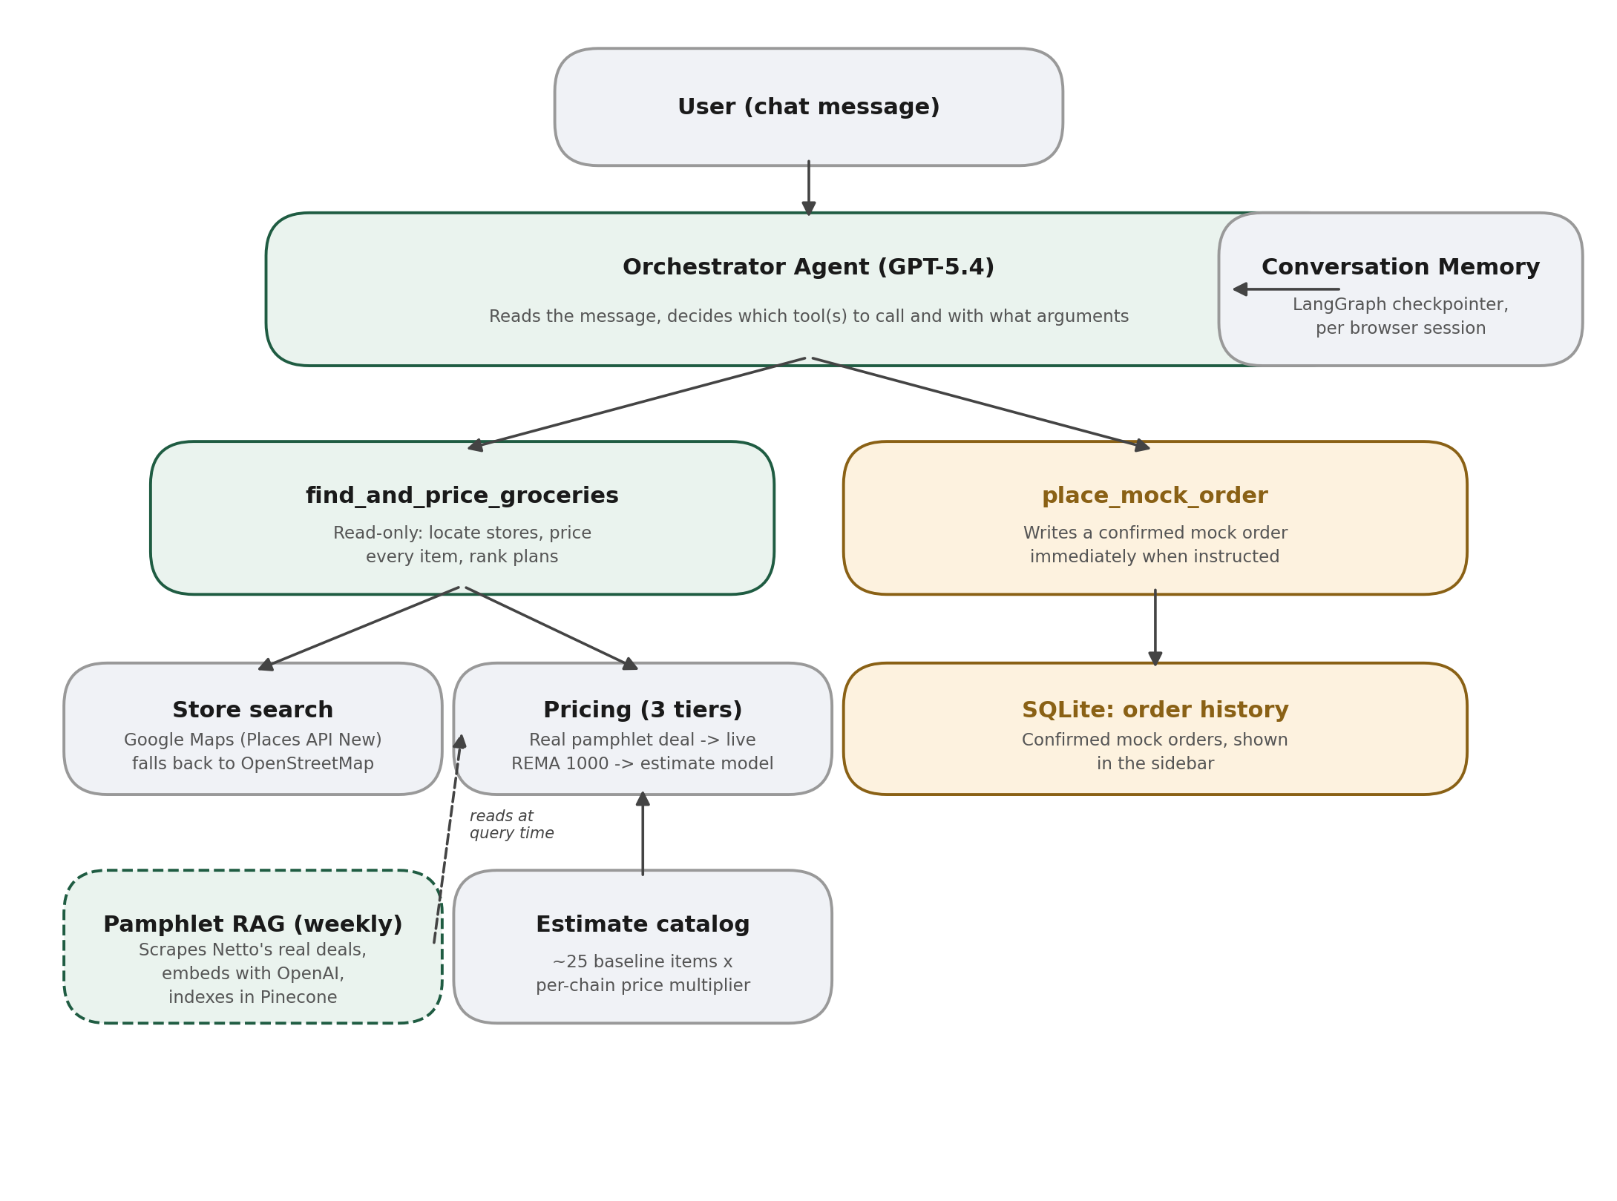

3.1 Orchestrator
A single system-prompted LLM call per turn. It extracts the grocery items, the Danish address, an optional budget, and whether the message is a direct, present-tense instruction to place an order - then calls find_and_price_groceries, place_mock_order, both, or neither, based on that reasoning.

3.2 Tools
find_and_price_groceries (read-only). Geocodes the address and finds nearby supermarkets (Google Maps if configured, OpenStreetMap otherwise), then prices every requested item at every nearby store through three tiers in order - this week's real Netto deals (Pinecone vector search over OpenAI embeddings), a live REMA 1000 lookup, and a labelled estimate model - and ranks single-store versus split-store plans.
place_mock_order (the one write action). Records a confirmed mock order immediately when the orchestrator judges the user gave a direct instruction to order. There is no real payment, checkout, or delivery system behind it.

3.3 Memory
Conversation memory: a LangGraph checkpointer keyed by a per-browser-session thread id, giving the orchestrator real multi-turn context - an address or item list given in one message can be reused in a later one without repeating it.
Order history: a local SQLite table of confirmed mock orders, shown in the sidebar so a user can see what they have "ordered" in past turns.

3.4 Background job
A weekly, out-of-band script scrapes Netto's homepage for its currently highlighted real deals, embeds each item name with OpenAI, and indexes them in Pinecone. This runs on its own schedule (cron/Task Scheduler), not inside the live request path - the pricing tool simply reads whatever this job last cached.

4. Known Limitations (stated up front, not hidden)

4.1 No human approval before placing a mock order
On the project owner's explicit instruction, there is no human-in-the-loop checkpoint before this tool's write action. place_mock_order writes a confirmed order the moment the LLM judges the user gave a direct, present-tense instruction to order ("place the order", "order it", "check out now") rather than a casual description of what they want to buy ("I want to buy milk and bread"). The system prompt is written with explicit positive and negative examples to sharpen that distinction, but this remains prompt engineering, not a hard guarantee - there is no code-level check confirming the user's exact wording before the tool fires. This is a defensible trade-off only because the order is a mock: no real payment, checkout, or delivery system exists behind it. If this tool were ever pointed at a real payment API, this exact design would place real orders on the LLM's judgement alone, which would not be an acceptable trade-off.

4.2 Real price coverage is narrow by necessity
There is no unified public API for real-time Danish supermarket prices, confirmed by checking the real options rather than assuming one exists. The official Tjek/eTilbudsavis API (which powers the interactive catalog viewers on netto.dk, foetex.dk, and bilka.dk) is private and paid, requiring a business relationship. Foetex's and Bilka's own sites are client-side rendered single-page apps with no server-side product data to scrape without a headless browser. Netto's homepage is the one exception: it server-renders a small set of highlighted deals as plain text, which is what the pamphlet RAG tier actually scrapes - typically five to ten items in rotation at any time, not a full catalog. Foetex and Bilka pricing therefore always falls to the labelled estimate model.

4.3 Estimate model is a rough guess, clearly labelled
When no real price exists anywhere, prices come from a REMA 1000 baseline scaled by a per-chain multiplier drawn from published cost-of-living comparisons, not from any live source. Every price in the UI is tagged real or estimated so this is never presented as more certain than it is.

4.4 Store discovery quality depends on the backend in use
OpenStreetMap's supermarket coverage is volunteer-maintained and can miss real branches (this is exactly what happened during development - a real nearby Netto did not appear until the store search was switched to Google Maps). Google Maps generally has better coverage but requires a paid-tier-eligible Google Cloud project with Places API (New) and the Geocoding API both explicitly enabled - the legacy Places API was frozen by Google in March 2025 and can no longer be newly enabled.

4.5 Conversation memory can resurface stale information
The orchestrator's checkpointer gives it real multi-turn memory, which is a feature, but it also means old tool results remain in context indefinitely. During testing the model was observed stating a price from several turns earlier as if it had just been fetched. The system prompt now explicitly instructs the model to only state a price that came from a tool call made in the current turn, but this is a mitigation, not a guarantee. The store cards rendered in the UI are the authoritative source of truth in any disagreement, since they render directly from a tool's structured output with no LLM involved in that path.

5. Project Documentation
Sections 1-3 above cover what the system does and how it is built. This section documents the data it draws on, representative prompts used while building it, and the development process.

5.1 Data sources
- Store locations - Google Maps (Geocoding API + Places API (New)) when configured, else OpenStreetMap (Nominatim + Overpass), both free and keyless.
- This week's real Netto deals - scraped directly from Netto's own homepage (the one chain of three whose highlighted deals are server-rendered, unlike Foetex and Bilka's JavaScript-rendered storefronts), embedded with OpenAI's text-embedding-3-small, and searched via a Pinecone vector index.
- Live prices - REMA 1000's unofficial but publicly reachable product search endpoint.
- Estimate model - a hand-built baseline of roughly twenty-five common grocery items at REMA 1000-tier prices, scaled by a per-chain multiplier sourced from published Danish cost-of-living comparisons.

5.2 Representative prompts used during development
- "Design a multi-step LangGraph pipeline for a grocery budget agent with a real human-approval interrupt before any write action."
- "Is it possible to use real Danish supermarket pamphlet data as RAG, updated weekly?"
- "I want Pinecone for RAG instead of BM25."
- "Change the app to take natural language input and reason about which tools to call."
- "The LLM keeps re-asking for an address it was already given - trace why and fix it."

5.3 Iterations, real bugs found, and how they were fixed
This project surfaced a genuinely long list of real, working-code bugs rather than being written once and left alone. The more instructive ones:
- Store search silently dropped real branches (including a real nearby Netto) due to a hardcoded top-6/top-8 cutoff on the number of candidate stores considered - raised the limit and confirmed via a test with a store deliberately placed 7th-nearest.
- The first pamphlet scraper assumed the product name and price sat next to each other in flattened page text; the real DOM has them in separate tags separated by React hydration comments, and the currency suffix itself is split across two more tags. Fixed by anchoring extraction on each deal card's product image (a single reliable attribute) and searching only within that card's own text.
- Pinecone rejected every upsert with a 'Vector ID must contain only ASCII characters' error, because vector IDs were built from raw item names containing Danish letters (æ/ø/å). Fixed by hashing the ID and keeping the real name only in metadata.
- Multi-turn conversation memory silently did not work: the orchestrator (and its in-memory checkpointer) was being rebuilt from scratch on every single message, because Streamlit re-runs the whole script on every interaction. Fixed with st.cache_resource so the same agent instance, and its checkpointer, persists across reruns.
- Once memory was fixed, a second bug appeared: every response re-showed store results from earlier turns, because the checkpointer returns the full accumulated message history, not just the current turn's new messages. Fixed by slicing off only the messages produced since the immediately preceding turn.
- The pamphlet real-price tier was gated behind matching one of roughly twenty-five hardcoded generic grocery categories before it would even attempt a semantic search - meaning a brand-specific item with an exact match sitting in the cache (a real Netto deal on a specific candy brand) was still reported as unpriced. Fixed by always trying the item's raw name against the pamphlet first, using the generic category only as an additional hedge query.
- The mock order tool's trigger condition ("the user asked to buy") was too loose - people routinely say "I want to buy milk and bread" simply to describe a shopping list, not to instruct a purchase. Tightened the system prompt with explicit matching and non-matching example phrasings.

5.4 Learnings
- A test double that cannot discriminate between different inputs (an embedding stub that returns an identical vector regardless of the query) can silently validate the wrong thing - a real-looking passing test result briefly looked like a classification bug when the actual bug was in the mock.
- Retry-then-degrade-then-label, first designed for one tool (the store locator), turned out to be a reusable pattern applied consistently across every external dependency in the system (Google Maps, REMA 1000, Pinecone, the pamphlet scraper) - worth designing as a shared principle rather than one-off error handling per tool.
- It is worth naming precisely which named agent pattern a design actually is (here: a single ReAct agent, not multi-agent) rather than leaving it ambiguous, since the distinction affects what a reader should expect to find in the code.
- Removing a safeguard (human approval before a write action) on request is a legitimate choice for a mock action with no real-world consequence, but the same design would not be an acceptable choice if the tool underneath it were ever pointed at something real - that distinction is worth documenting explicitly rather than leaving implicit.

6. Repository & Setup
Full run instructions, environment variable requirements, and architecture detail live in README.md and FRAMEWORK.md in the project repository. In summary:
- Python 3.12, virtual environment, pip install -r requirements.txt.
- Required: OPENAI_API_KEY (orchestrator reasoning and pamphlet embeddings).
- Optional, each with a documented fallback if omitted: PINECONE_API_KEY (real weekly deals), GOOGLE_MAPS_API_KEY (better store coverage).
- streamlit run streamlit_app/app.py to launch.
- python scripts/refresh_pamphlets.py to populate real weekly Netto deals (run weekly in production; a one-off run is enough for a demo).

